Computer Science 91903 3.4
Description of project:
My project is a web-based app designed to assist my target audience of gym goers in accessing libraries of music. Many users currently switch between multiple apps to access workout plans and music, which creates inconvenience during training sessions.
My app allows users to upload their own MP3 files and organise them into custom workout playlists. Users can also import audio from publicly accessible links. In addition to music management, the app tracks workouts and provides exercise suggestions based on user preferences. The goal of the app is to improve convenience, motivation, and workout efficiency by combining music and workout tracking into a single web app.
End Users:
Primary users are gym-goers aged 16–30 who regularly use music during workouts and want a centralised platform for managing both workout routines and playlists.
Requirements:
Functional requirements:
- Users must be able to create an account and login into their designated profile.
- Users must be able to upload MP3 files already stored on their device.
- The system must allow the user to play this audio.
- The app must collate all MP3 files that have been uploaded into a playlist.
- Users must be able to create, edit, and delete playlists.
- Users must be able to add or remove songs from playlists.
- Users must be able to track workouts by logging exercises, sets, and repetitions.
- VERY IMPORTANT: User workout and playlist data must be saved and retrievable for future sessions.
Non-functional requirements:
- The application must have a responsive design that works on mobile, tablet, and desktop devices.
- Pages should load quickly to avoid delays during workouts.
- The interface must be easy to navigate while users are exercising.
- Audio playback should run smoothly without buffering or crashes.
- Buttons should be large and accessible for quick interaction during workouts.
- The design should remain consistent across all pages/features.

Iterations:
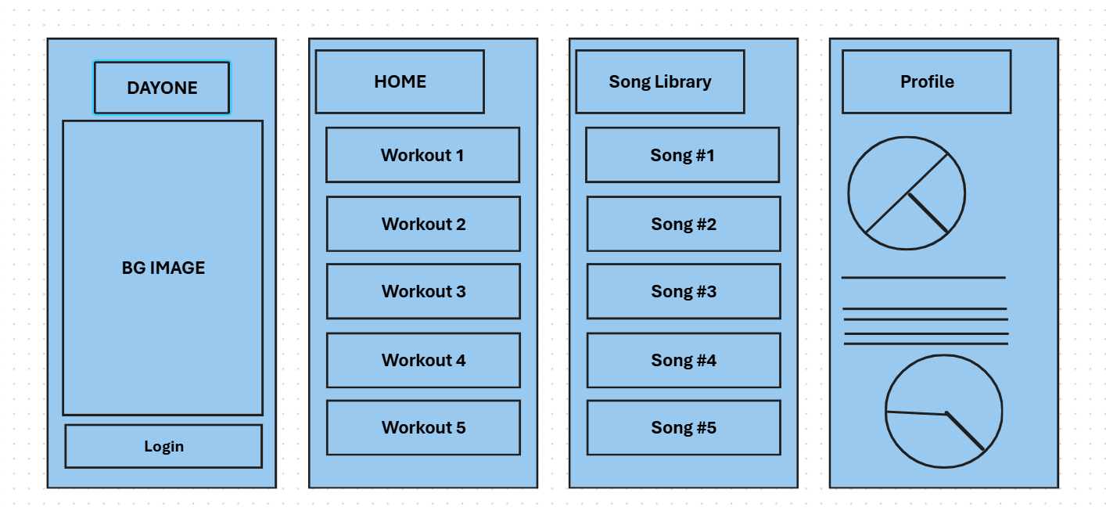
WIREFRAME Iteration #1:
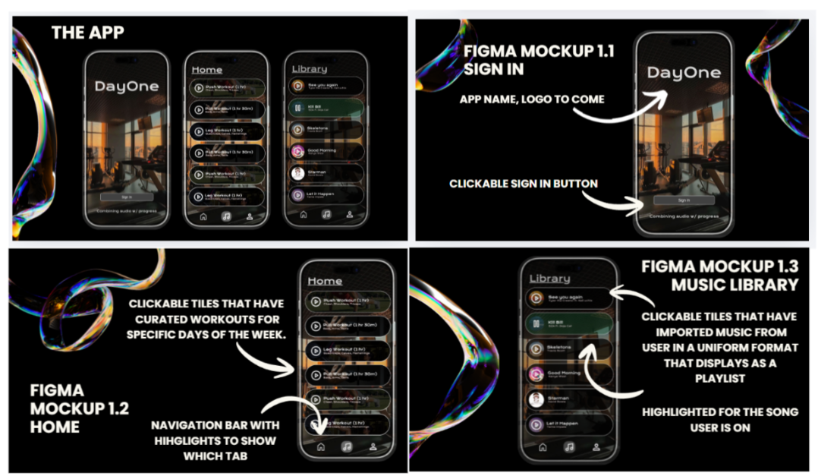
FIGMA Iteration #2:

Iteration #3
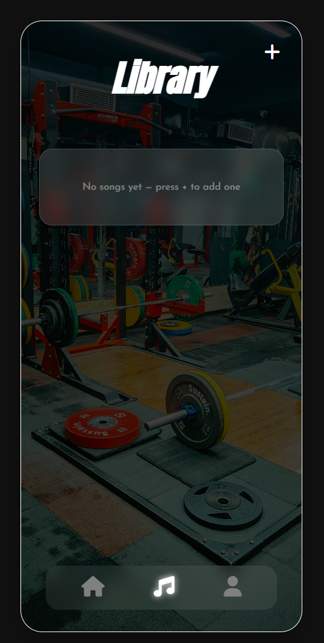
https://www.youtube.com/watch?v=POjqDyEp4WY
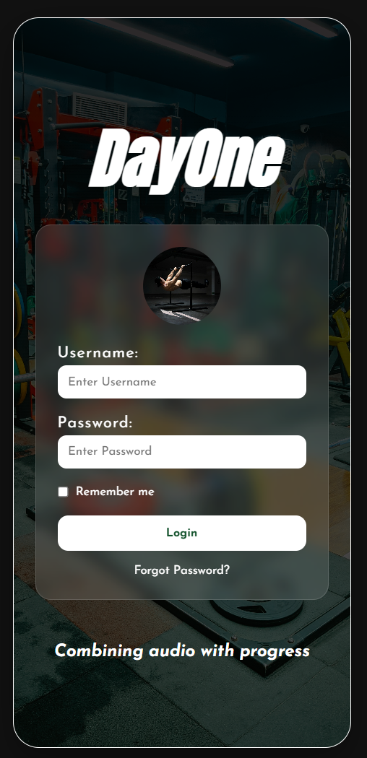

Specifications:

Development Log:
https://trello.com/b/TMNXIBiB/computer-science-dayone-app

Testing:
Feature | Test Done | Expected Res | Actual Res | Improvement
Login system | Enter correct uername/password | User is taken to the homepage | Worked as expected | NA
Login System | Enter incorrect information | Error message pops up | Alert shown correctly | NA
Song Upload | Upload MP3 file | Song is stored and appears in playlist | Song successfully uploaded and saved | NA
Playlist loading | Refresh page | Songs load from database | Songs correctly fetched from MongoDB | None needed  However, initially in one of my earlier iterations, I did not have my application connected to MongoDB’s database and therefore the songs would disappear.
Play audio | Click play button | Song starts playing | Audio plays correctly | Improved UI highlighting for active song
Pause audio | Click pause while audio playing | Song pauses | Worked correctly | NA
Delete song | Click delete button | Song removed from UI and database | Song deleted successfully | NA
Mobile responsiveness | View on small screen | Layout fits phone frame | Works but overflow in early version | Adjusted padding and scroll area

Complex components:
Uploading MP4 files and automatically converting to MP3 – complex.
Extracting audio from link.
Saving user data.

Examples of complex techniques include:
● non-core functionality
● sophisticated digital effects
● applying industry standards or guidelines
● responsive design for use on multiple devices
● integration of original media assets
● dynamic data handling and interactivity
● automation through scripts

Implications:
Social: Many users may not be able to afford multiple music streaming subscriptions or may listen to niche workout playlists that are difficult to access. My app attempts to make music more accessible by allowing users to upload their own MP3 files into one location.
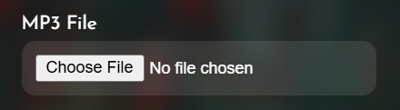
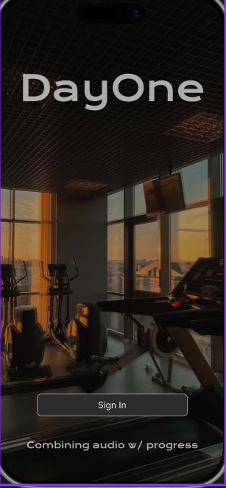
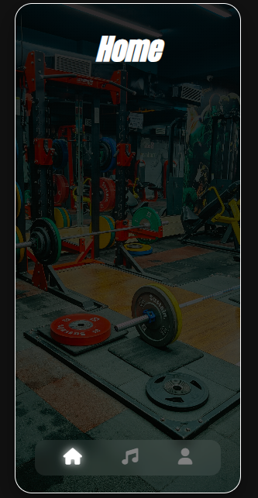
Intially my design featured dark themes and was very masculine this however does not consider my full target audience as females are less inclined to want to engage with this sort of UI. Based on feedback, I adjusted the design to focus more on general fitness motivation rather than extreme bodybuilding culture so it would appeal to a broader audience.

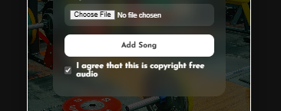
Intellectual property: A major intellectual property implication in my project is copyright ownership of music files. My application allows users to upload MP3 files into their personal music library, which creates potential copyright concerns because many songs are owned by artists, record labels, or streaming platforms such as Spotify, Apple Music, or YouTube. To combat this problem, I implemented a checkbox system where the user is responsible for agreeing that any audio they upload to the app is both royalty free and available for creative use.

Cultural: The web app does not contain any images relating to cultural or religious ideologies this means that not only will these users find no issue with my app in this regard but it also opens my app to a wider audience. This is because people will not be restricted by what they believe in or where they are from when using my app.

Aesthetics:
A key aesthetic implication of my project was ensuring that the interface looked visually appealing to my target audience of gym-goers while still remaining easy to use.
The app needed to communicate motivation, energy, and fitness culture through its design. I used a dark colour scheme with high contrast white text because this reflects common design conventions used in fitness and music apps such as Spotify and Nike Training Club.

BEFORE AFTER

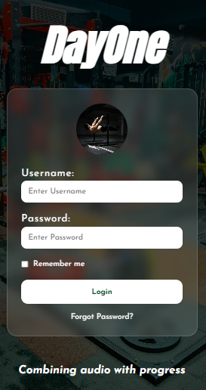
The darker interface also helps create a modern and professional appearance that matches gym environments. I used bold typography such as the Anton font for headings to create a strong and energetic visual style, while Josefin Sans was used for readability throughout the interface. This helped create clear visual hierarchy and made important features such as uploading songs and navigating the app more noticeable.

During testing, one of my friends who tested the app said it looked cluttered because there were too many input fields and unnecessary features such as image uploads. Based on this feedback, I simplified the interface by removing unnecessary elements and focusing on the core purpose of uploading and playing music.
I also followed common design conventions such as using clear navigation icons, consistent spacing, and simple button interactions so users could quickly understand how the app works without needing instructions.
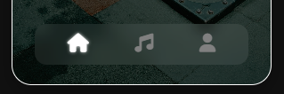
Health and Safety:

A health and safety implication of my project is ensuring that the app promotes safe workout habits and does not negatively affect users during exercise. Since the target audience is gym-goers, users may interact with the app while lifting weights, using machines, or performing exercises where distraction could be dangerous.
DETAILS TO COME FOR IN THE APP ON SAFETY WITHIN THE GYM WHILE LISTENING TO MUSIC

One risk is that users may spend too much time navigating playlists or changing songs during workouts, which could reduce concentration and increase the chance of injury. To reduce this risk, I designed the interface to be simple and quick to use, allowing users to upload songs and play music with minimal steps.

legal
ethical
privacy
accessibility
usability ● functionality ● aesthetics ● sustainability and future proofing ● end-user requirements ● health and safety

RENDER JS encountered paywall
I used expressjs to help in my development of creating an HTTP JSON API.
It works by listening to the users inputs in the front end for example file upload or saving songs. The backend then listens to the users requests and communicates with the MongoDB database and sends back data.
How it works??
This tells the express server to log into my cloud MongoDB database using my secure connection string. Once this is successful, the bridge is open.
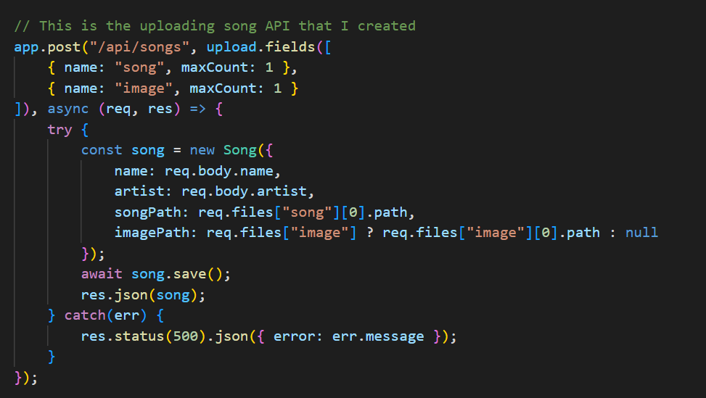
When a user uploads a song, the API creates a new record using my Mongoose model and pushes it to the database:

Testing:
I attempted to upload a song but it was not connecting and providing an error message:

Project management techniques:

Decomposition:

Trialling components:

Testing functionality

Feedback and refinement

Version control

Relevant implications

Evidence of process

Iterative / Agile development

User Journey map:
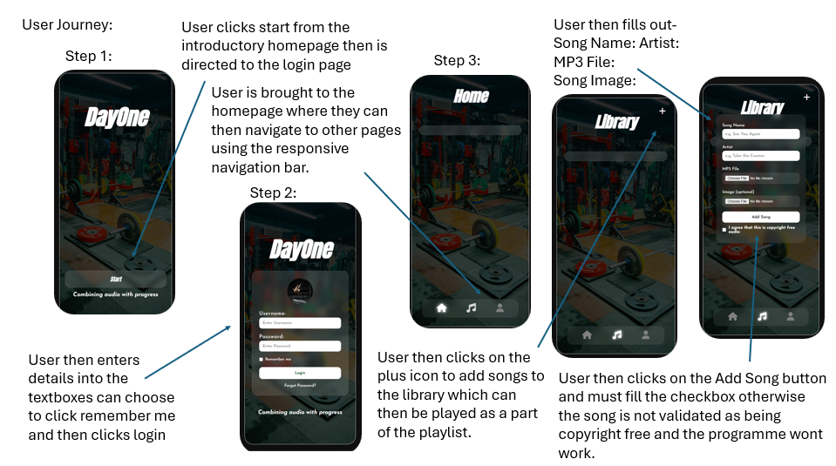

Decomposing the outcome into smaller components:
Component #1: Login
Component #2: Upload files
Component #3: Play files
Component #4: Store files

Trialling the components of the digital technologies’ outcome

Trialling uploading the files:

Component #4: Store files
Feature | Test Done |  | Expected Res |  | Actual Res |  | Improvement
Files open upon “upload MP3 pressed. |  | Uploading MP3 file |  | Song is stored and appears in playlist |  | Song successfully uploaded and saved |  | NA
Playlist loading |  | Refresh page |  | Songs load from database |  | Songs correctly fetched from MongoDB |  | None needed  However, initially in one of my earlier iterations, I did not have my application connected to MongoDB’s database and therefore the songs would disappear.
Play audio |  | Click play button |  | Song starts playing |  | Audio plays correctly |  | Improved UI highlighting for active song
Pause audio |  | Click pause while audio playing |  | Song pauses |  | Worked correctly |  | NA
Delete song |  | Click delete button |  | Song removed from UI and database |  | Song deleted successfully |  | NA
Mobile responsiveness |  | View on small screen |  | Layout fits phone frame |  | Works but overflow in early version |  | Adjusted padding and scroll area

Research Summary:

